WEATHER APP WEBSITE

A PROJECT REPORT

# BACHELOR OF SCIENCE

SUBMITTED BY

CHIKKALA SRINU

# TEAM ID ; LTVIP2023TMID02110

# SRI AMAL DEGREE COLLEGE

(Recognised by Andhra University SRI AMAL DEGREE

COLLEGE, ANAKAPALLI,VISHAKAPATNAM, ANDHRAPRADESH

# INTRODUCTION

# A Front End Developer creates websites and applications using web languages such as HTML,CSS and Jawascript that allow users to access and interact with the site or app.when you visit a website,the design elements you see were created by front-end developer.

# DECLARATION

# Experienced and ambitious web design professional seeking an opportunity as a Front-End developer.detail oriented professional with an associate degree in computer science and five years of experience with a web development firm.Pursuing front-end developer roles so I can use my specialised SEO and debugging skills.

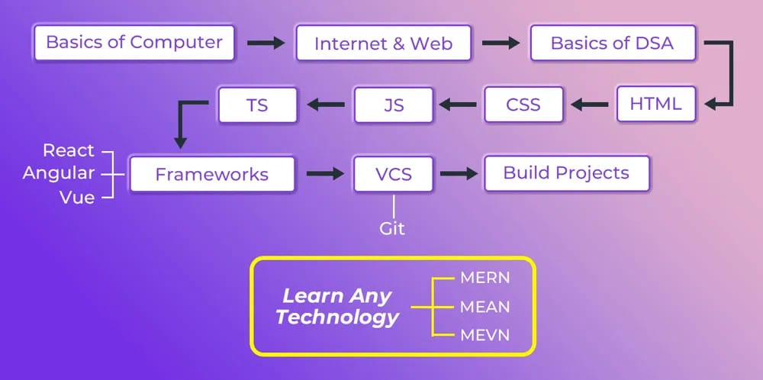

SOFTWARE USED

Code Editor I used for this project is VS Code, It is used to code complex piece of prograrns and to develop complex projects. Further technologies I used for this project are HTMLS, CSS, JS.

2.1 HTMLS

It is the code for creating web pages, using tags and other commands that a browser rends and eOiiVCi'tS into the iiOt'iÄiiil web pages that people see.

2.2 css

CSS is the language for describing the presentation of Web pages, including colours, layout, and fonts.

Result / Output

Home Section:

It displays my name, my current work, status and where I am from on the topic also has navigation bar which displays other tabs of my website and my contact detail shortcuts on top right.

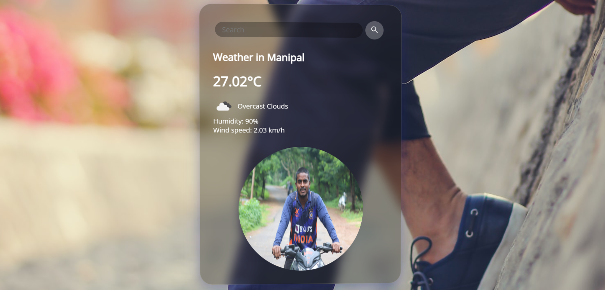

About Section:

1. It displays a quick introduction for me and provides my skills and education
2. It displays weather in manipal
3. Developed a weather app that tracks the users location 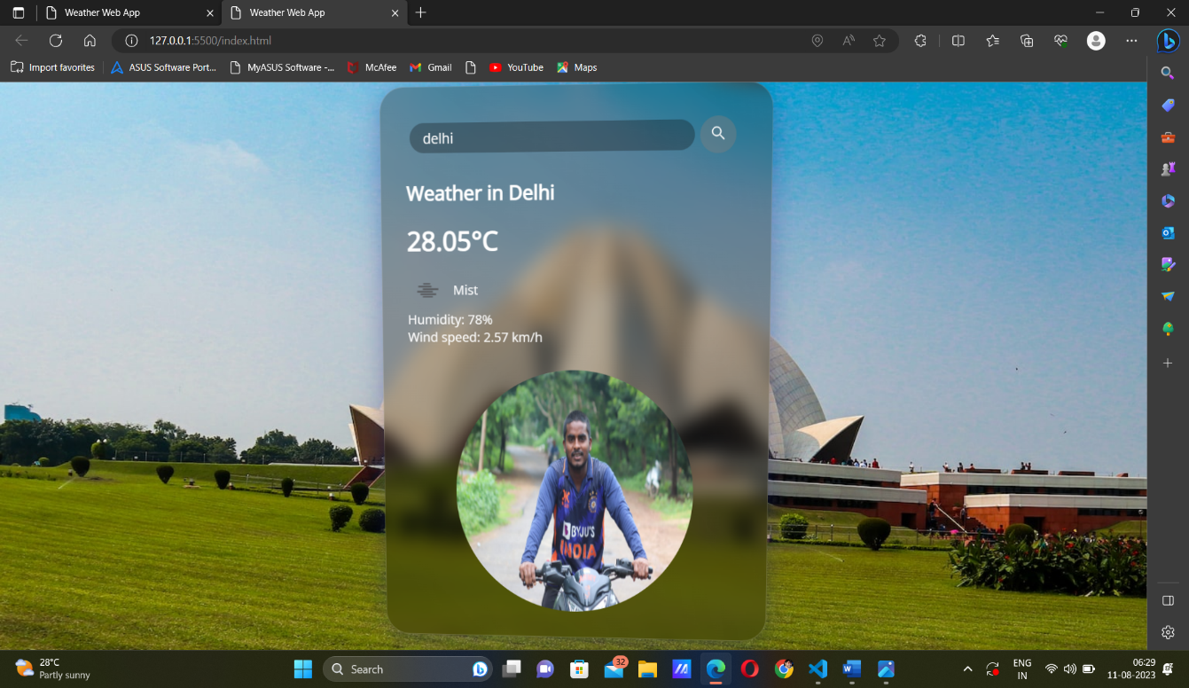

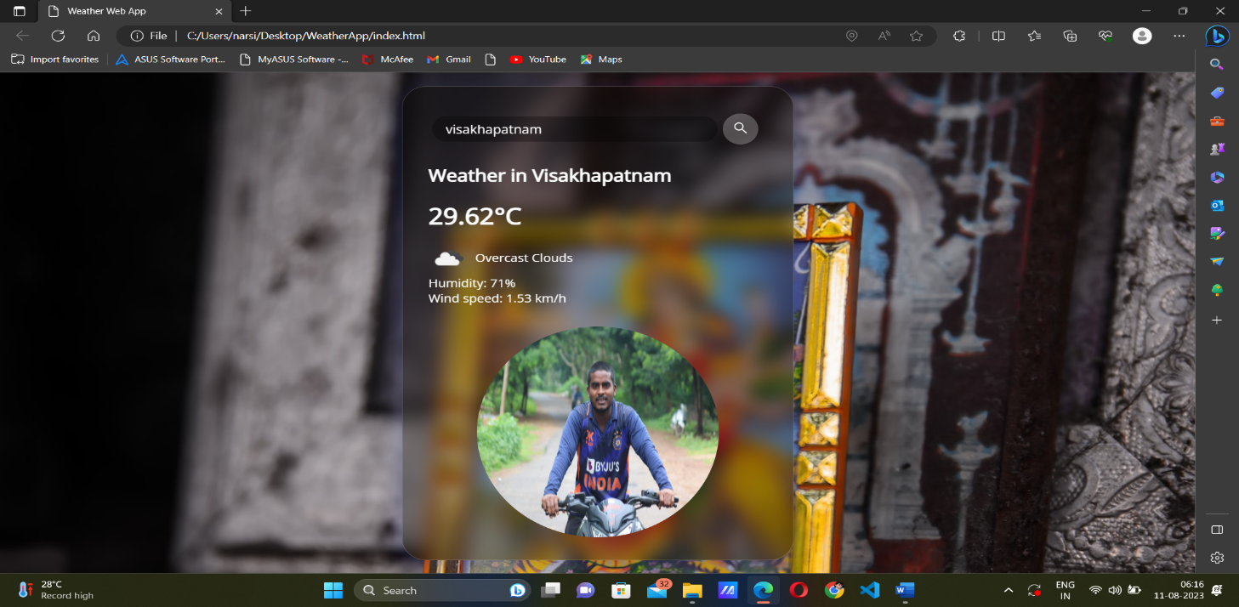

Contact Details Section:

This section has all the links listed below: 1.faceboook

1. Twitter
2. WhatsApp
3. Instagram
4. Linked In

ADVANTAGES:

* Visual design
* Cross-browser compatibility
* Responsive design
* Performance optimization
* Emerging technologies
* Continuos improvement
* Accessibility

DISADVANTAGES:

* Updates can introduce issues
* Technical debt

* Developers coming onto the project will need to understand the framework in order to contribute

* You Always Run Out of Ideas

Applications:

Commonly known as the interface of an application,is the layor or element that the user has the ability to use,see,and interact with through buttons,images,interactive elements,navigational menus,and text.

Conclusion;

Building a weather app project allows you to apply your web development skills to real -word application.also,it helps you to better understand DOM manipulation,Event handling,CSS styling,APIs and more.I hope that by following the steps in this post,you have successfully created your weather app using HTML,CSS and Javascript

Future Scope:

Every project whether large or small has some limitations no matter how diligently developed.In some cases,limitations are small while in other cases they may be broad also.The new system has got some limitations.Major areas where modifications can be done are as follows:

1.Our system does not have weather information for foreign countries or cities.

2.There is no provision for complaint handling so further it can be added.